Farhad Ahmed

Computer Networking

11/28/18

**Lab – ICMP Pinger**

*Running ifconfig:*

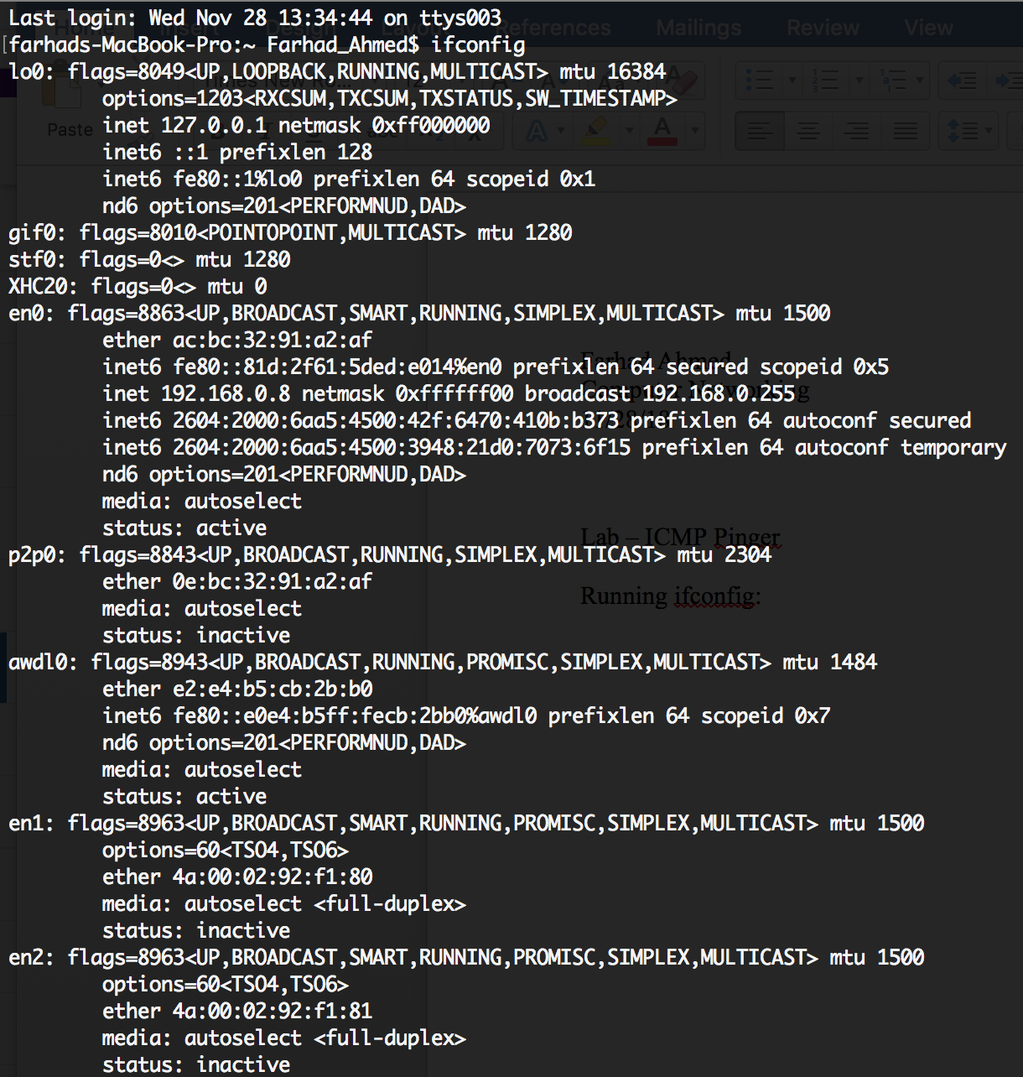

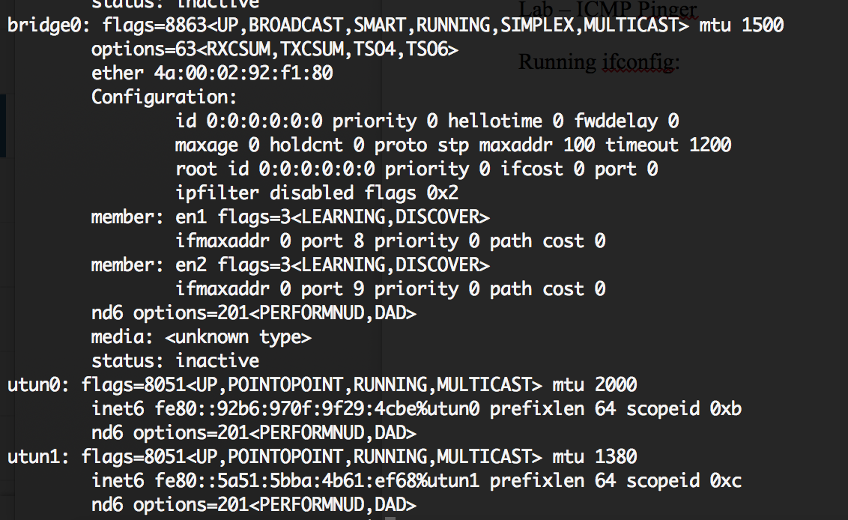

First ping: google.com

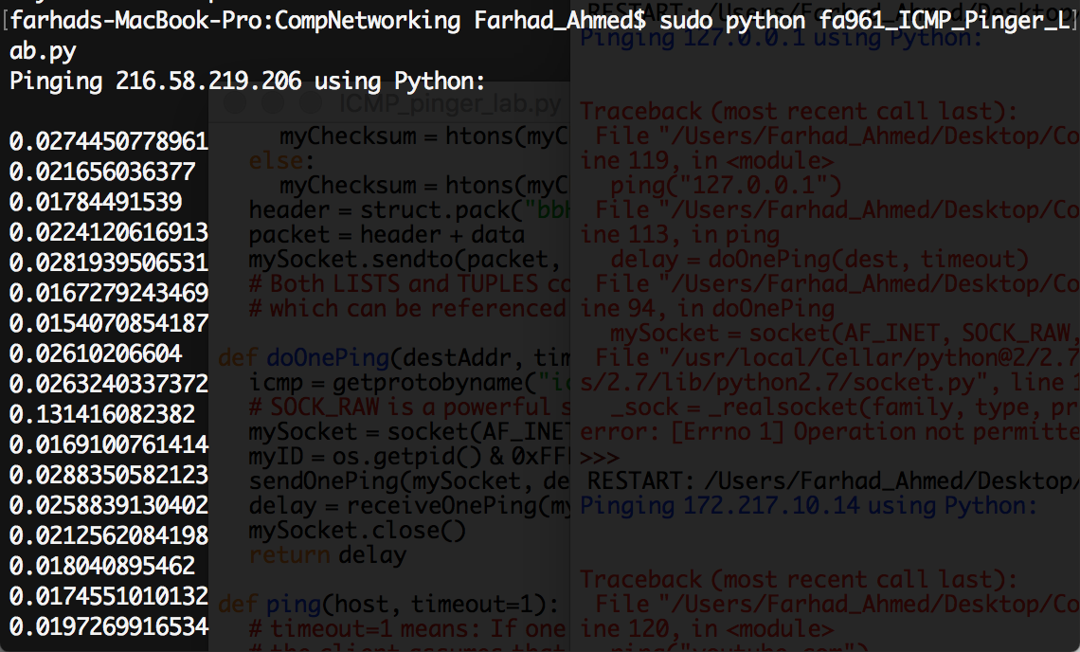

Second Ping: youtube.com

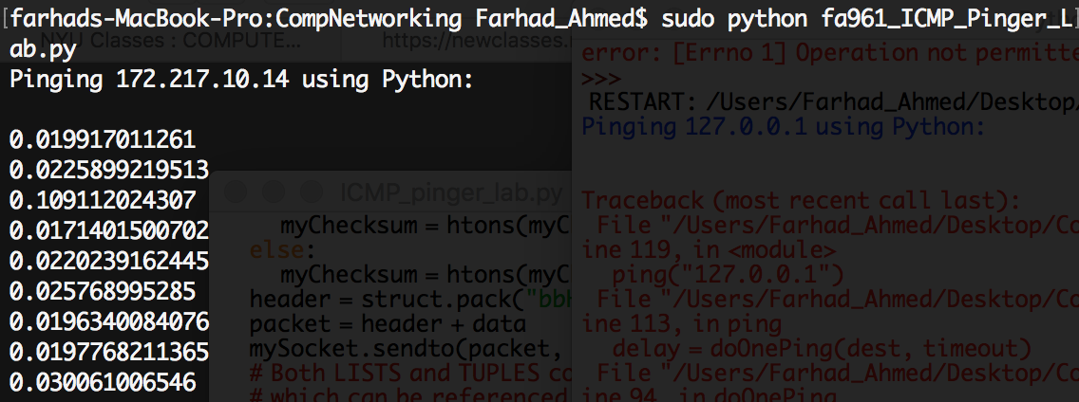

Third Ping: bbc.co.uk

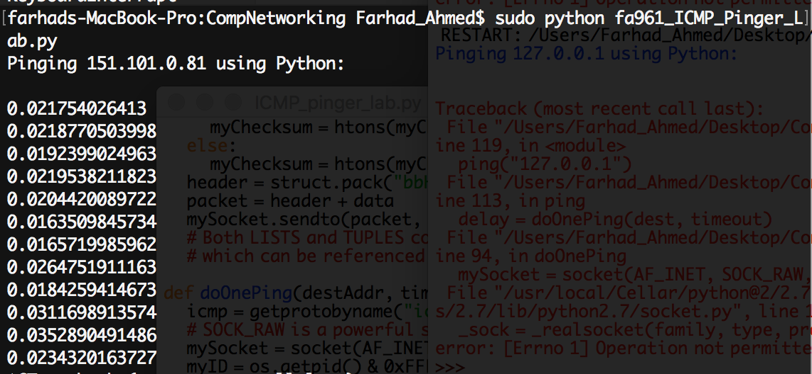

Fourth Ping: au.int

